ﻟﻠﻌﻮدة اﻟﻰ اﻟﻤﻮﻗﻊ اﻛﺘﺐ ﻓﻲ ﺑﺤﺚ ﺟﻮﺟﻞ
اﻟﻤﻌﻠﻢ اﻟﺘﻌﻠﻴﻤﻲ
ALMUALM.COM

ﺗﻢ ﺗﺤﻤﻴﻞ ورﻓﻊ اﻟﻤﺎدة ﻋﻠﻰ ﻣﻨﺼﺔ

اﻟﻤﻌﻠﻢ اﻟﺘﻌﻠﻴﻤﻲ


Kingdom of Saudi Arabia English Language
Ministry of Education ….. elementary Grade
……..Education Directorate period Exam
………………… School \20
Student's Name : class:

- General questions ……\ 4 marks
A.Answer the questions 1-What does he do?
a-Good afternoon b- He's a lawyer c- No. he isn't.
2-What time did you get up yesterday?
a-Yesterday, I got up at 5:30 b- I usually get up at 5:30 c- Yes, I did.
3-What time do you take a bath?
a- She plays basketball at 3:00 b-I usually take bath at 10:00 c- No , I can't.
4-Where do they work?
a-They work in airport. b-She works in hospital. c-I am work in school.
- Controlled Writing ……\ 1 marks
A-reorder.
grow up, - a firefighter – I want – When I – to be
……………………………………………………………………………………
- Reading short sentence
A-Put ( ✔ ) or ( X ) ……\ 4 marks



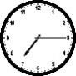
B.Match



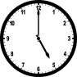

1- I usually finish the school at | 1:30 ( | )
2- It's a quarter past seven ( | )

1-It's 5 o'clock.
2-A doctor helps sick people and works in a hospital.

- Grammar ……\ 4 marks

A-Choose the correct answer.
- What does she ( do – does – doing ) ?
- I usually ( eat – ate – eats ) lunch at 1:00.
- Yesterday, I ( do – does – did ) my homework at ten o'clock. 4-Where do you ( work – works – working)?
……\ 5 marks
- Vocabulary

A.write the correct word under each picture
( cheese – ink - clock - baker - astronaut )



- Orthography ……\ 2 marks

A. Fill in the missing letters
Sh Kn ph gh

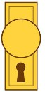
…..one Ni…..t ….ip …..ob
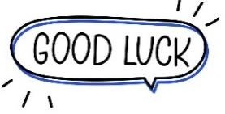

Your teacher …..:…………………………….

Kingdom of Saudi Arabia English Language
ﻧﻤﻮﺫﺝ ﺍﻹﺟﺎﺑﺔ
Ministry of Education ….. elementary Grade
……..Education Directorate period Exam
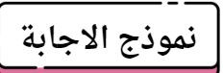
………………… School \20
Student's Name : class:




- General questions ……\ 4 marks
A.Answer the questions 1-What does he do?
a-Good afternoon b- He's a lawyer c- No. he isn't.
قناتي على التلقرام yesterday? up get you did time 2-What
a-Yesterday, I got up at 5:30 b- I usually get up at 5:30 c- Yes, I did.
3-What time do you take a bath? Asma's world
a- She plays basketball at 3:00 b-I usually take bath at 10:00 c- No , I can't
4-Where do they work?
a-They work in airport. b-She works in hospital. c-I am work in school.
- Controlled Writing ……\ 1 marks
A-reorder.
grow up, - a firefighter – I want – When I – to be
When I grow up, I want to be a firefighter.
- Reading short sentence
A-Put ( ✔ ) or ( X ) ……\ 4 marks

1- I usually finish the school at | 1:30 ( |  | X | )
2- It's a quarter past seven ( | ✔ ) | ❖

1-It's 5 o'clock. | 2
2-A doctor helps sick people and works in a hospital. | 1

Grammar ……\ 4 marks
A-Choose the correct answer.
- What does she ( do – does – doing ) ?
- I usually ( eat – ate – eats ) lunch at 1:00.
- Yesterday, I ( do – does – did ) my homework at ten o'clock. 4-Where do you ( work – works – working)?
……\ 5 marks
- Vocabulary

A.write the correct word under each picture
( cheese – ink - clock - baker - astronaut)

- Orthography ……\ 2 marks
A. Fill in the missing letters ½Mark for each
Sh Kn ph gh

phone Night ship knob

Your teacher …..:…………………………….
clock | baker | astronaut | ink | cheese



اختبار ف رتي – الصف .
It is seven o'clock. | He is a doctor. | I eat my lunch.
-  | -  | - 

Midterm Exam

20 / | الدرجة | / | الفصل |  | االسم ثالثي:

- What is the time ? I. Choose the right answer : 2
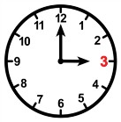
  - It is one o'clock. B. It is three o'clock.
- What does the firefighter do?
  - He puts out fires . B. He flies plane .
II. Choose  OR 
 |  |  |  |  |  |  |  |  |  |  |  |  | 3
 |  |  |  |  |  |  |  |  | 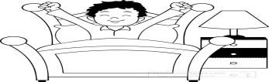
 |  |  |  |  | III. Do as shown between brackets:
 |  |  |  |  |  |  |  |  |  |  |  |  | 2
 |   1-one . ( Choose ) |  |  |  |  |  | hundred |  | thousand |  |  | thirty
 | 2. is – a – she – teacher ( rearrange) |  |  |  |  |  | زز ززززززززززززززززززززززززززززززززززززززززززززززززززززززززززززززززززززززززززززززززززززززززززززززززززززززززززززززززززززززززززززززززززززززززززززززززززززززز
 |  | IV. Choose the correct word:
 |  |  |  |  |  |  |  |  |  |  |  |  | 2
 |  | 1 – I usually up at 5:00 . |  |  |  | A. got |  |  | B. get |  |  | C. go
 |  | 2. does she do ? She is a nurse . |  |  |  |  | A. What |  | B. Who |  |  | C. Where
V. Choose the correct word:
 |  |  |  |  |  |  |  |  |  |  |  |  | 6
 |  |  |  | 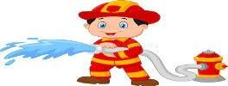 |  |  |  |  |  |  | 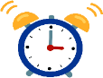
 | Eat |  | Take a bath | Engineer |  | Baker |  | Teacher |  |  | Clock
 | Brush |  | Get up | Firefighter |  | Nurse |  | Doctor |  |  | Ring
VI. Choose the correct letter:
5


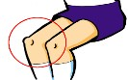

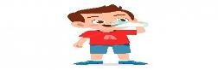

_ ilot dri_ _ ri_ _t _ _ee ri_ _ b nk ph gh ng
p kn gh kn nk
TEACHER :

اختبار ف رتي – الصف .

Midterm Exam
ﻧﻤﻮﺫﺝ ﺍﻹﺟﺎﺑﺔ

Model answer

منوذج اجابة

What is the time ?
- Choose the right answer :
2
A. It is one o'clock. B. It is three o'clock.

What does the firefighter do?
A. He puts out fires . B. He flies plane .

- Choose  OR  3

It is seven o'clock. | He is a doctor. | I eat my lunch.
-  | -  | - 

- Do as shown between brackets: 2

- one . ( Choose )
hundred
thousand
thirty

- is – a – she – teacher ( rearrange)
زز ززززززززززززززززززززززززززززززززززززززززززززززززززززززززززززززززززززززززززززززززززززززززززززززززززززززززززززززززززززززززززززززززززززززززززززززززززززززز

1 – I usually up at 5:00 .
IV. Choose the correct word:
  - got
  - get
2
  - go

- does she do ? She is a nurse .
  - What
  - Who
  - Where

6
V. Choose the correct word:

Eat | Take a bath | Engineer | Baker | Teacher | Clock
Brush | Get up | Firefighter | Nurse | Doctor | Ring

VI. Choose the correct letter:
_ ilot | dri_ _ |   ri_ _t | _ _ee | ri_ _
b | nk | ph | gh | ng
p | kn | gh | kn | nk

5

TEACHER :

Total



Midterm Test
Kingdom of Saudi Arabia Ministry of Education
. Education Directorate
… Intermediate School
20

20 / | الدرجة | / | الفصل |  | االسم ثالثي:

General Questions
/ 3
Choose the correct answer:

– What does your dad do ?
A . I am playing. B . He is a doctor.

– What does the firefighter do?
  - He puts out fires . B. He flies plane .

– What is the time? 10:30
A . It is ten o'clock. B. It is ten thirty.




Read the sentence then choose or  :
/ 3
Reading short sentences

1. It is seven o'clock. |   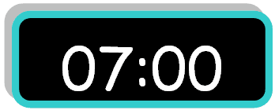  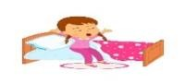  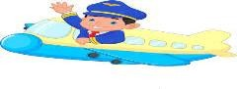   |   
2. I eat my lunch. |    |   
3. He is a pilot. |    |   
Grammar
/ 3

Choose the correct answer:

1 – I usually up at 5:00 .
- yesterday, I home at 1:00 .
- does she do ? She is a nurse .
  - go
- come
- who
- get
B. came
B. what
C. got
C. go
C. where

Controlled writing
/ 2

Do as shown between brackets:

2- One . ( choose ) | hundred | Thousand | Thirty
3– she - a – teacher – is. ( rearrange ) | .....................................................

Vocabulary
/ 5

Put the right word under its picture:
clock – doctor – firefighter – baker - get up

 |  | 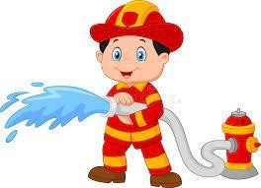 | 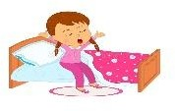 | 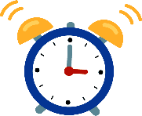
Orthography
/ 4
Fill in the missing letters:
ng – kn – gh -nk

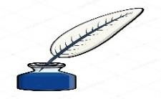 |  | 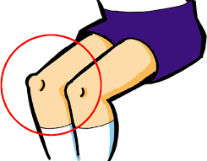 | 
  i_ _ |   ri_ _ t | _ _ ee |   ri_ _

Good luck T.

Total

Midterm Test
Kingdom of Saudi Arabia Ministry of Education
. Education Directorate
… Intermediate School
20

 | ……………………. | Elementary | Grade
نموذج إجابة

General Questions
/ 3
Choose the correct answer:
ﻧﻤﻮﺫﺝ ﺍﻹﺟﺎﺑﺔ

– What does your dad do ?

A . I
am playing.
B . He is a doctor.

– What does the firefighter do?
  - He puts out fires . B. He flies plane .

– What is the time? 10:30
A . It is ten o'clock. B. It is ten thirty.
Reading short sentences
/ 3

Read the sentence then choose or  :

1. It is seven o'clock. |              | 
2. I eat my lunch. |  | 
3. He is a pilot. |  | 
Grammar
/ 3

Choose the correct answer:

1 – I usually up at 5:00 .
- yesterday, I home at 1:00 .
- does she do ? She is a nurse .

  - go
- come
- who

- get
B. came
B. what

C. got
C. go
C. where

Controlled writing
/ 2

Do as shown between brackets:

2- One . ( choose ) | hundred | Thousand | Thirty
3– she - a – teacher – is. ( rearrange ) | She is a teacher .

Vocabulary
/ 5

Put the right word under its picture:
clock – doctor – firefighter – baker - get up

baker | doctor | firefighter | get up | clock
Orthography
/ 4
Fill in the missing letters:
ng – kn – gh -nk

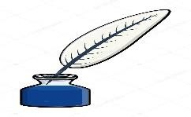
  ink |   right |   knee |   ring

Good luck T.

