اختبار نهاية الفصل الثاني ( الدور )
للعام الدراسي 1446هـ المادة /اللغة االنجليزية
الدرجة كتابة :
الصف :رابع، خامس،سادس ( )
30
`` زمن اإلجابة / ساعة ونصف
اململكة العربية السعودية وزارة التعليم
اإلدارة العامة للتعليم ابملنطقة الشرقية مكتب التعليم ابخلرب
مدرسة .










…………………………الجلوس رقم………………………………………………………….………………………………………………………… الطالب اسم


Answer the general questions:
- What do you like to do for fun?
I like to climb ……………………
- Did you win?
No, we………………..
- Which activities do you do in your free time?
I like to play games.
- Can you run quickly? Yes, I …………………….
- Which places in nature do you like visiting?
I like to visit ………………….
- Could you swim when you were six?
Yes, I…………………..


Reorder the words:
- the books! / drop / Don’t
………………………………………………………………………………………………………………………………....
- jumped / the rope. / She
………………………………………………………………………………………………………………………………….
- play / I want to / board games.
…………………………………………………………………………………………………………………………………..
- Did you / the car. / fix
………………………………………………………………………………………………………………………………….
- Happily. / playing / She is
…………………………………………………………………………………………………………………………………..

Match the questions to their answers:

- What is your favorite story? Yes, I did. I like football.
- Did you play football today? My favorite story is the city mouse.
- Do you want to make a model? No, I couldn’t
- Could you ride a horse? No, I want to play hide and seek.


أقلب الورقة

Choose the correct words:
- I ( score – scored) three goals yesterday.
- She didn’t ( drop – dropped ) the cup.
- Did he ( play – played ) video games last night.
- I want to go out, ( but – and ) it’s raining now.
- He’s walking ( quick – quickly ).


Circle the correct word:
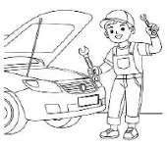  fixed e-mailed | 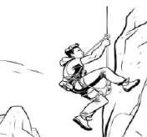  climbed invited |   cave Earth | 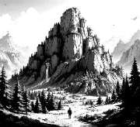  loudly mountain | 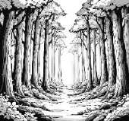  robbed forest | 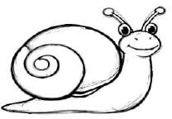  vlogging snail
Circle the missing letter:

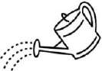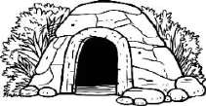


انتهت األسئلة
إعداد/ أ.عوضه االمحري
Tex_ing  n  t | Wate_ed  s  r | Qu_etly  i  g | Ca_e  v  z

اختبار نهاية الفصل الثاني ( الدور )
للعام الدراسي 1446هـ المادة /اللغة االنجليزية
الصف :رابع، خامس،سادس ( )
زمن اإلجابة / ساعة ونصف
اململكة العربية السعودية وزارة التعليم
اإلدارة العامة للتعليم ابملنطقة الشرقية مكتب التعليم ابخلرب
الدرجة كتابة :
مدرسة ``
ﻧﻣوذج اﻻﺟﺎﺑﺔ

…………………………الجلوس رقم………………………………………………………….………………………………………………………… الطالب اسم
30

Answer the general questions:

1- What do you like to do for fun?
I like to climb trees أو a tree 2- Did you win?
No, we didn’t

ﻣوﻗﻊ اﻟﻣﻌﻠم اﻟﺗﻌﻠﯾﻣﻲ

3- Which activities do you do in your free time?
I like to play video أو board games 4- Can you run quickly?
Yes, I can.
5- Which places in nature do you like visiting?
أو أي كلمة من صفحة ٥٨ mountains visit to like I
6- Could you swim when you were six?
Yes, I could.

Reorder the words:
- the books! / drop / Don’t Don’t drop The books!
- jumped / the rope. / She She jumped the rope.
- play / I want to / board games.
I want to play board games.
- Did you / the car. / fix Did you fix the car?
- Happily. / playing / She is She is playing happily.

Match the questions to their answers:



- What is your favorite story? Yes, I did. I like football.
2
1
4
3
- Did you play football today? My favorite story is the city mouse.
- Do you want to make a model? No, I couldn’t
- Could you ride a horse? No, I want to play hide and seek.

أقلب الورقة



Choose the correct words:
- I ( score – scored) three goals yesterday.
- She didn’t ( drop – dropped ) the cup.
- Did he ( play – played ) video games last night.
- I want to go out, ( but – and ) it’s raining now.
- He’s walking ( quick – quickly ).

Circle the correct word:
fixed e-mailed | climbed invited | cave Earth | loudly mountain | robbed forest | vlogging snail
Circle the missing letter:



انتهت األسئلة
إعداد/ أ.عوضه االمحري
Tex_ing  n  t | Wate_ed  s  r | Qu_etly  i  g | Ca_e  v  z

اﻟدراﺳﻲ ﺧاﺗﺑﺎر ﻣﺎدة )ﻟاﻠﻐﺔ اﻻﻧﺟﻠﯾزﯾﺔ( ﻟاﻔﺻلﻟادراﺳﻲﻟاﺎﺛﻧﻲﻠﻟﻌﺎم  ١٤٤٦ ـھﻠﻟﺻف اﻟرﺑاﻊ ﻟﺧﺎﻣس ﻟﺳﺎدس |  | ﻟاﻣﻣﻠﻛﺔ اﻟﻌرﺑﯾﺔﻟاﺳﻌودﯾﺔ ارة اﻟﺗﻌﻠﯾم  ﻹادارة اﻟﻌﺎﻣﺔ ﻟﻠﺗﻌﻠﯾم ﺑﻣ ﻓظﺔ  . .........
ﻟادرﺟﺔ ﻣن ٣٠ / |  | دﻣرﺳﺔ .
ﻟاﻣﺻﺣﺢ /  ﻟاﻣراﺟﻊ/ |  | ﻟازﻣن / ﺳﺎﻋﺔ وﻧﺻف
ﻻاﺳم / ﻟاﺻف / م اﻟﺟﻠوس ): (

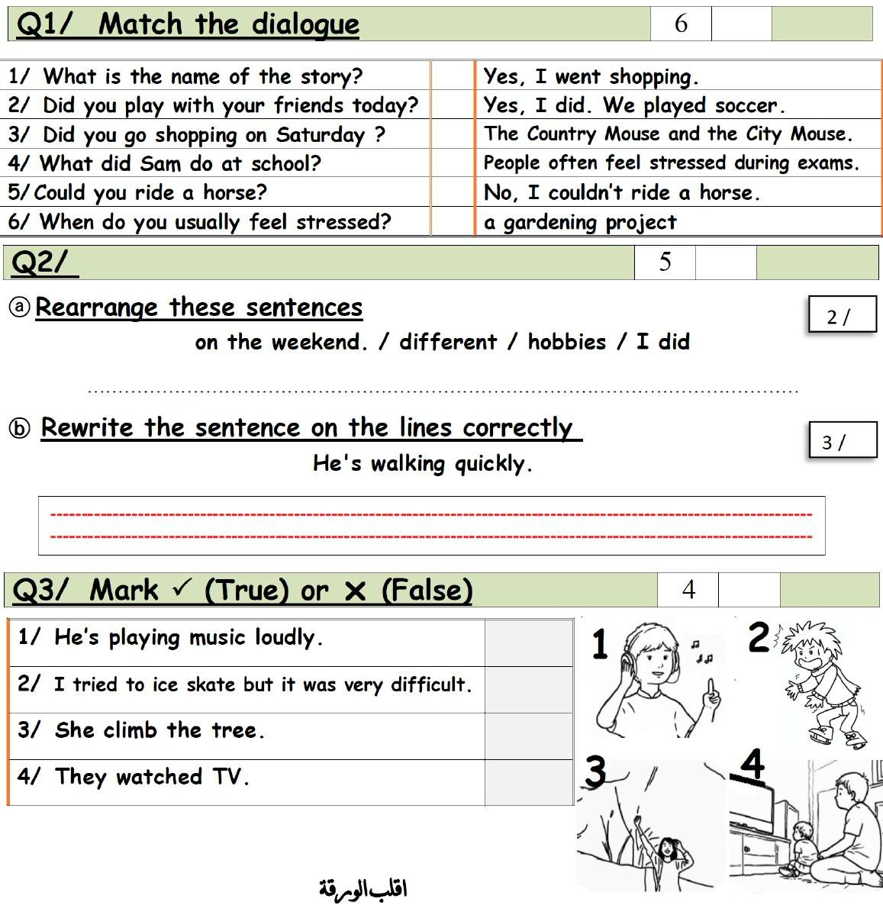
1

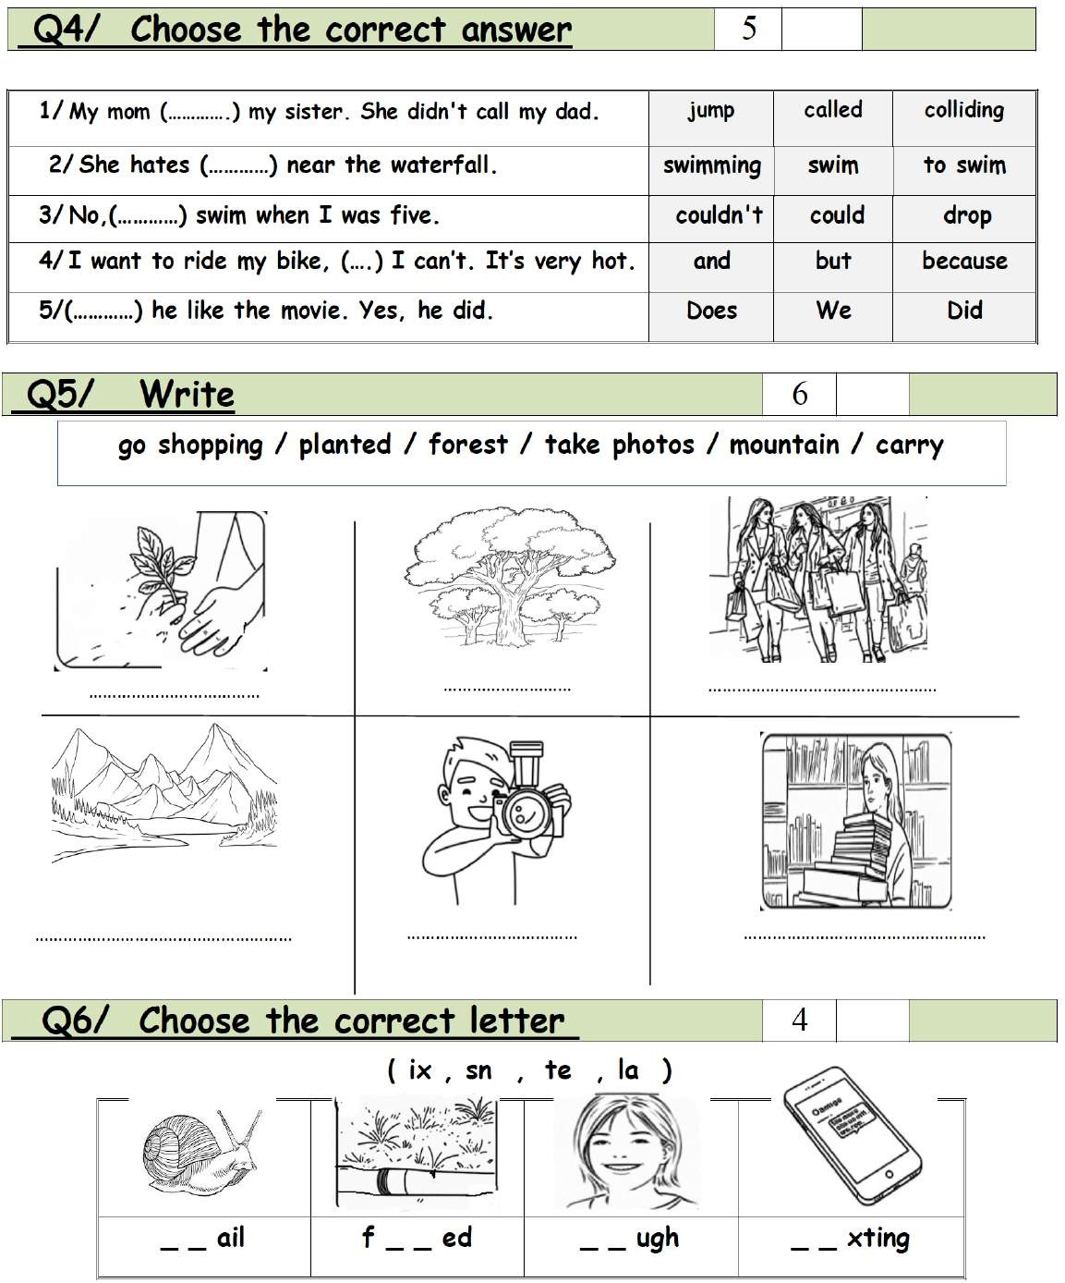
* **************************************************************************************************
íò‰Ảt kãjt
7^rrl^e pÓl êi^érÚĬ géĬ ÄÚ. xéf‘çe t‚fÂ ë†ÓÊ : D^t p
2

اﻟدراﺳﻲ ﺧاﺗﺑﺎر ﻣﺎدة )ﻟاﻠﻐﺔ اﻻﻧﺟﻠﯾزﯾﺔ( ﻟاﻔﺻلﻟادراﺳﻲﻟاﺎﺛﻧﻲﻠﻟﻌﺎم  ١٤٤٦ ـھﻠﻟﺻف اﻟرﺑاﻊ ﻟﺧﺎﻣس ﻟﺳﺎدس |  | ﺟﺎﺑﺔ  اﻟﺗﻌﻠﯾﻣﻲ | ﻟاﻣﻣﻠﻛﺔﻧ اﻟﻌﻣرﺑﯾوﺔذﺳﻌوجدﯾﺔاﻻ  ارة اﻟﺗﻌﻠﯾم  ﻹاﻣدارةواﻟﻗﻌﺎﻣﺔﻊ ﻟﻠﺗﻌاﻠﯾﻟم ﺑﻣﻣﻌﻓﻠظﺔم  . .........
ﻟادرﺟﺔ ﻣن ٣٠ / |  |  | دﻣرﺳﺔ .
ﻟاﻣﺻﺣﺢ /  ﻟاﻣراﺟﻊ/ |  |  | ﻟازﻣن / ﺳﺎﻋﺔ وﻧﺻف
م اﻟﺟﻠوس ): ( | ﻟاﺻف / |  | ﻮذجاﺟﺎﺑﺔ | ﻻاﺳم /



3
2
1
6
5
4

I did different hobbies on the weekend.

T T F
T
1

planted forest go shopping

mountain
take photos carry

s n i x l a t e

* **************************************************************************************************
íò‰Ảt kãjt
7^rrl^e pÓl êi^érÚĬ géĬ ÄÚ. xéf‘çe t‚fÂ ë†ÓÊ : D^t p
2

