Total

Kingdom of Saudi Arabia Ministry of Education


. Education Directorate
… Intermediate School

Midterm Test units 1 & 2

Second Intermediate Grade
20
Name ………………………………… Class ………………………………
Comprehension
/ 4

Read the following then answer the questions:

Last weekend, I went to a new shopping mall that opened last month. The shopping mall is so huge and has five gates. Inside the mall, there are many stores and a place for people to pray. Also, the mall has a food area with more than 5 different restaurants.
A- Put (√ ) for true or ( ᵡ ) for false :

1. The shopping mall opened last week. | ) (
2. The mall has five gates. | ) (
B- Choose the right answer:
Grammar

1-The mall is so . | small | huge | crowded | beautiful
2-Inside the mall there is a place for people to . | study | play | pray | sleep
/ 5

Choose the right answer:

1- We here for the festival.
A. is B. am |  | C. are | D. do
.2 - are you doing? | Fine, thanks
A. Where B. How |  | C. When | D. which
3 - What are you now?
A. doing B. do |  | C. does | D. did
4 - I martial arts films.
A. am liking B. likes |  | C. like | D. liking
5 - The apple is the boxes . 
A. under B. on |  | C. in | D. between

A- Choose the best answer to fill in the blank:
1. are good places for meeting people.
A. Hotels | B. Schools | C. Room | D. Playground
2. Good night. tomorrow.
A. Good morning | B. Good bye | C. See you | D. Good afternoon
3- Are you here for the conference? No, I’m here on with my family.
A. hotel | B. vacation | C. study | D. playing
4- He is in the library.
A. playing a game | B. reading a book | C. watching a film | D. eating a sandwich
B- Put the right word under its picture:
pizza , ladder
, webcam
, credit card , karate
/ 5

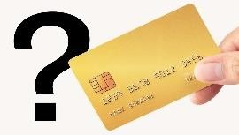 | 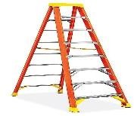 | 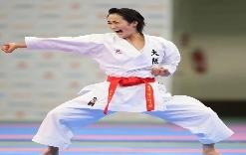 | 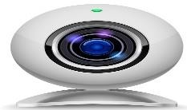 | 
Orthography
/ 2

Choose the correct letter:

1. I’d like to intro_uce you to Joe. | d | h | k
2. The soup s_ells good . | t | m | b

Good luck T.


مراسل : يت خاص MOHAMADZGA@
M_zaid0
T.ME/MOHAMADZAID
محمد زايد االسمري _ قنا : يت

Total

Kingdom of Saudi Arabia Ministry of Education
. Education Directorate
… Intermediate School

Midterm Test units 1 & 2

Second Intermediate Grade – Model Answer
20
Name ………………………………… Class ………………………………
Comprehension
/ 4

Read the following then answer the questions:

Last weekend, I went to a new shopping mall that opened last month. The shopping mall is so huge and has five gates. Inside the mall, there are many stores and a place for people to pray. Also, the mall has a food area with more than 5 different restaurants.
A- Put (√ ) for true or ( ᵡ ) for false :

1. The shopping mall opened last week. | ) ᵡ (
2. The mall has five gates. | ) √ (
B- Choose the right answer:
Grammar

1-The mall is so . | small | huge | crowded | beautiful
2-Inside the mall there is a place for people to . | study | play | pray | sleep
/ 5

Choose the right answer:

1- We here for the festival.
A. is B. am |  | C. are | D. do
.2 - are you doing? | Fine, thanks
A. Where B. How |  | C. When | D. which
3 - What are you now?
A. doing B. do |  | C. does | D. did
4 - I martial arts films.
A. am liking B. likes |  | C. like | D. liking
5 - The apple is the boxes . 
A. under B. on |  | C. in | D. between

Vocabulary
/ 4

A- Choose the best answer to fill in the blank:
1. are good places for meeting people.
A. Hotels | B. Schools | C. Room | D. Playground
2. Good night. tomorrow.
A. Good morning | B. Good bye | C. See you | D. Good afternoon
3- Are you here for the conference? No, I’m here on with my family.
A. hotel | B. vacation | C. study | D. playing
4- He is in the library.
A. playing a game | B. reading a book | C. watching a film | D. eating a sandwich
B- Put the right word under its picture:
pizza , ladder
, webcam
, credit card , karate
/ 5

 | 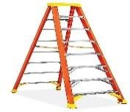 |  | 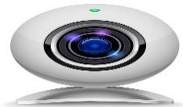
credit card | ladder | karate | webcam | pizza
Orthography
/ 2

Choose the correct letter:

1. I’d like to intro_uce you to Joe. | d | h | k
2. The soup s_ells good . | t | m | b

Good luck T.

مراسل : يت خاص MOHAMADZGA@
M_zaid0
T.ME/MOHAMADZAID
محمد زايد االسمري _ قنا : يت

