Total
20

Kingdom of Saudi Arabia Ministry of Education

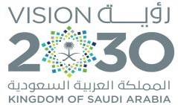
. Education Directorate
… Intermediate School

Midterm Test units 1 & 2

First Intermediate Grade

Name ………………………………… Class ………………………………
Comprehension
/ 4

Read the following then answer the questions:
My name is Abdullah, I was born in Jeddah. I am from Saudi Arabia and I am 22 years old.
I am a student at the Business Administration College. I have got one brother and one sister.
In my free time, I watch TV and play computer games. And I also play basketball every weekend. I like to have a good time with my friends, but I hate shopping for clothes.
A- Put (√ ) for true or ( ᵡ ) for false :

1. He has got two sisters. | ) (
2. In his free time, he watches TV. | ) (
B- Choose the right answer:
Grammar

1-He was born in . | Riyadh | Jeddah | Abha | Tabuk
2-Abdullah is a . | doctor | teacher | student | driver
/ 5

Choose the right answer:

1- You my best friend. .
A. is | B. am | C. are | D. do
2 - I’m a student. name is Aisha
A. his | B. my | C. your | D. she
3 - Our vacation is May.
A. on | B. in | C. at | D. under
4 - old are you? | I’m fifteen .
A. Where | B. How | C. When | D. which
5 - Sara a nurse .
A. am | B. are | C. is | D. she

Vocabulary
/ 4

A- Choose the best answer to fill in the blank:
1. I need a pair of to cut this paper.
A. book | B. scissors | C. pencil | D. pen
2. Good night, Fatima. , Mona
A. Good morning | B. Good bye | C. Good night | D. Good afternoon
3- January is the first of the year.
A. month | B. week | C. day | D. hour
4- your books. Look at page 12.
A. help | B. write | C. open | D. cut
B- Put the right word under its picture:
Parrot , dolphin , pencil , notebook , listen
/ 5

 |  | 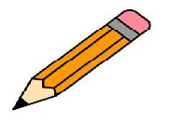 |  | 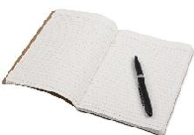 |  |  | 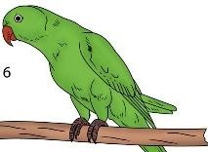
 |  |  |       Orthography |  |  |  |  | / 2
Choose the correct letter:

1. The food on planes is terrib_e. | l | h | k
2. Our visit is on Thurs_ay. | t | d | b

Good luck T.


MOHAMADZGA@
مراسل : يت خاص
M_zaid0
T.ME/MOHAMADZAID
محمد زايد االسمري _ قنا :يت

