
Kingdom of Saudi Arabia
Ministry of Education
………… Education Directorate............
…………..……………….. Intermediate School

Total
المجموع | تحريري | شفهي
20 | 10 | 10

Second Period Exam
First Intermediate Grade

Name ………………………………… Class ………………………………
__________________________________________________________________________________________
/ 2
Comprehension

Read the following then answer the questions:

My house is where my family lives. It is white. It is big. There are four bedrooms. We have a kitchen and three bathrooms. Our family room is where we like to watch television together. When people come over, we eat in the dining room. We have a playroom in the basement. We have a swing in the backyard.
I love my house.
A- Put (√ ) for true or ( ᵡ ) for false :

( ) | 1. My house is big.
( ) | 2. There are two bathrooms.

B- Choose the right answer:

blue | green | white | red | 1-The house is ______.
swing | ball | garage | tree | 2- We have a ______ in the backyard.
_________________________________________________________________
/ 2.5
Grammar

Choose the right answer:

1- _______ you from Saudi Arabia ? Yes, I am .
A. Is B. Have C. Are D. Do
2 - She _______ a sister .
A. have B. has C. do D. does
3 - _____ ____ four people at the table .
A. There is B. There are C. There isn't D. Is there
4 - She lives ______ Riyadh .
A. in B. on C. at D. under
5 - They have three_____ .
A. child B. childs C. children D. boy

/ 2
Vocabulary

A- Choose the best answer to fill in the blank:
1. What is your ________ ? I am Chinese.
D. country | C. city | B. nationality | A. address
2. I come from a big ______ . I have three sisters and four brothers.
D. garden | C. house | B. car | A. family
3- The ______ is in the garage.
D. stove | C. motorcycle | B. shower | A. tree
4- ________ A place to take exercise.
D. Gym | C. Supermarket | B. Street | A. School
B- Put the right word under its picture:
 | 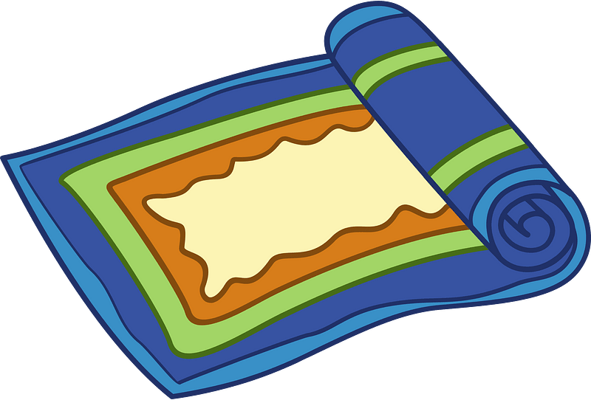 | 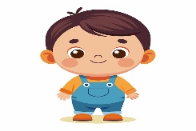 | 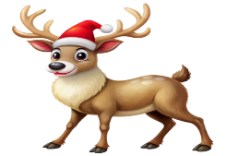 | 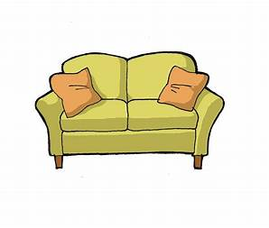
/ 2.5
reindeer - rug - child - sofa - turn right

_______________________________________________________________________________
/ 1
Orthography

Choose the correct letter:
r | c | n | 1. Mr. Ali works in a ba__k .
u | o | e | 2. She was looking at herself in the mirr__r.

Good luck T.

