1
1– What are you going to be when you grow up ?

I. CHOOSE
A. I am going to be an engineer. B. I am going to the market.
2– What is your favorite dish?

A. I am cooking pasta. B. My favorite dish is pizza .
المملكة العربية السعودية |  |  | اسم الطالب/ ......................................
وزارة التعليم
إدارة التعليم بمنطقة |  |  | المادة : انجليزي
مدرسة : |  |  | الزمن :
 |  |  | الصف : فصل ( )
شفهي | تحريري |  |  | المجموع
10 / | 10 / |  |  | 20 /
Top goal2 اختبار الفترة الثانية الفصل الأول - للعام الدراسي 1447– لغة انجليزية –– للصف
اسم الطالب / هـ الفصل /

2. CHOOSE OR
1.5

She bakes a cake.
That is an airport.
That is an engineer .

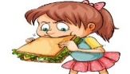




3. DO AS SHOWN BETWEEN BRACKETS
1.5

1- going to /We /be /managers/ are /. / (Rearrange ) ……………………………………………………………………………
Coffee | Water | Chips | 2 - _________ is good for your body . (choose)

4. CHOOSE
1

going to | may | 1- I am ________ to be an artist.
using | use | 2- If I don't have sugar, I _____ honey.

4. CHOOSE
3
pilot - waiter - honey

 | 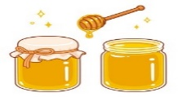 | 


2

Choose the correct letter:

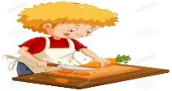 | 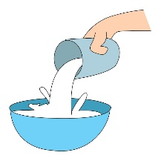 | 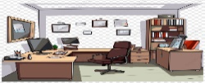 | 
c_t | pou_ | Offi_e | Fashio_ designer
a | t | c | t
u | r | d | n

___________________________________________________________________________________________________________________________________________________________________________________________________________________________________
Controlled writing

4

Good luck T.

