1
1– What kind of stories do you like?
I. CHOOSE
A. I like stories about animals. B. I like English.
2– What after-school activity do you do ?

A. No, I am not . B. I play computer games.
المملكة العربية السعودية |  |  | اسم الطالب/ ......................................
وزارة التعليم
إدارة التعليم بمنطقة |  |  | المادة : انجليزي
مدرسة : |  |  | الزمن :
 |  |  | الصف : فصل ( )
شفهي | تحريري |  |  | المجموع
10 / | 10 / |  |  | 20 /
Top goal1 اختبار الفترة الثانية للفصل الأول - للعام الدراسي 1447– لغة انجليزية –– للصف الرابع
اسم الطالب / هـ الفصل /

2. CHOOSE OR
1.5

She is reading a book.
They are in the classroom.
He planted flowers.






3. DO AS SHOWN BETWEEN BRACKETS
1.5

1 played / Carta / a soccer / yesterday. ( rearrange ) …………………………………………………
quietly | quickly | loudly | 2 - He is walking ________. (choose )
4. CHOOSE
1

scoring | scored | scores | 1- She _____ a goal yesterday.
so | and | but | 2- I go swimming _____ play tennis.

3
4. CHOOSE
jump - plant - vlogging

 | 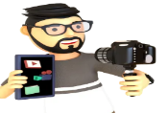 | 


2

Choose the correct letter:

 |  | 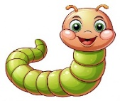 | 
Vi_eo games | ting_te | _rom | ter_mon
n | c | n | k
d | x | w | s

___________________________________________________________________________________________________________________________________________________________________________________________________________________________________
Controlled writing

4

Good luck T.

