
Kingdom of Saudi Arabia
Ministry of Education
………… Education Directorate............
…………..……………….. Intermediate School

Total
المجموع | تحريري | شفهي
20 | 10 | 10

Second Period Exam
Second Intermediate Grade

Name ………………………………… Class ………………………………
__________________________________________________________________________________________
/ 2
Comprehension

Read the following then answer the questions:

Last winter my family and I went to France. At the beginning of our trip, we went on a cruise on the River Seine. It was a wonderful experience. There were so many interesting things to see there. We visited the Eiffel tower and took lots of pictures. They were amazing! My parents and I also tried horse riding. My brother didn’t want to go anywhere near the animal. You see, he was afraid. I really want to visit France again. It’s beautiful and there are many things to see there!
A- Put (√ ) for true or ( ᵡ ) for false :

( ) | 1. We went to France last summer .
( ) | 2. They went on a cruise on the River Seine .

B- Choose the right answer:

Eiffel tower | park | sea | pyramids | 1-They visited the ____ and took lots of pictures
Skiing | swimming | swing | horse riding | 2- My parents and I also tried ________.
_________________________________________________________________
/ 2.5
Grammar

Choose the right answer:

1- We would like ___________ Makkah .
A. visiting B. to visit C. visit D. visits
2 - There is _______ juice .
A. any B. most C. some D. many
3 - There aren't _____ fries.
A. most B. much C. some D. any
4 - He _______at home last night.
A. were B. was C. is D. are
5 - I didn’t hear __________. I was asleep.
A. anything B. nothing C. something D. thing

/ 2
Vocabulary

A- Choose the best answer to fill in the blank:
1. They eat in food courts or _________.
D. plains | C. restaurants | B. Schools | A. streets
.2. I'd like a piece of ___________
D. cup | C. cake | B. juice | A. water
3- We looked at the birds through _________.
D. glasses | C. sky | B. binocular | A. mirror
4- He was talking on his __________.
D. cell phone | C. window | B. car | A. lamp
B- Put the right word under its picture:
/ 2.5
 | 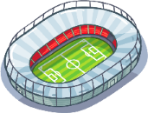 | 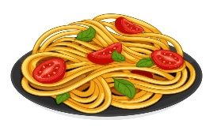 | 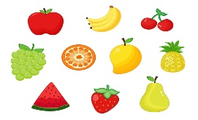 | 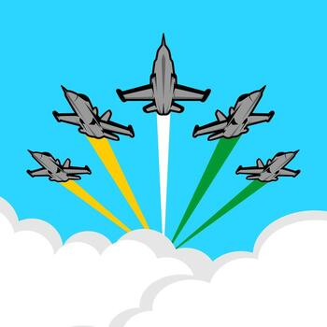

Pasta - sleepy - stadium - aerobatic - fruit

_______________________________________________________________________________
/ 1
Orthography

Choose the correct letter:
k | b | g | 1. The word calli_raphy means “beautiful writing.”
d | p | r | 2. He didn’t see the sto_ sign .

Good luck T.

