
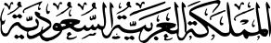
المادة: لغة انجليزية

وزارة التعليم
الإدارة العامة للتعليم بمنطقة ---------
ثانوية ---------------------------------
اختبار منتصف الفصل الدراسي الأول 1447ه

اختبار الفترة الثانية الفصل الأول 1447هـ

20

ABOKHALEDAMER
0557325813
الاسم: ....................................................... | الصف: الأول الثانوي | الزمن: حصة
Look at the picture and write the correct number: (6M)
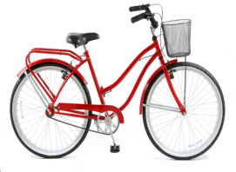
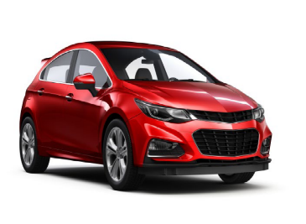
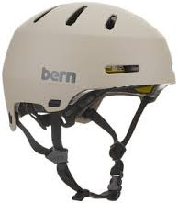
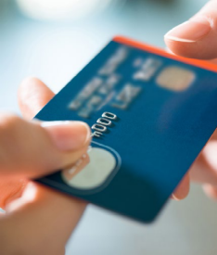

1. helmet 2. car 3. knife 4. bicycle 5. driver 6. credit card
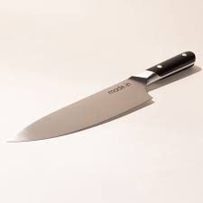

( ) ( ) ( ) ( ) ( ) ( )
Choose the correct answer: (7M)
1. I did my homework ( himself – myself – herself ).
2. Hassan helped his mom ( herself – himself – itself ).
3. He didn’t go to school ( so – because – but ) he was sick.
4. He is a very good learner. ( So I am. – So he does. – So am I.)
5. The car ( has – is – will ) been repaired in the workshop.
6. The silver ring is ( small – smaller – smallest ) than the gold ring.
7. This new doorbell (smells – tastes – sounds) just like a bird.
Match the Real Talk: (4M)
1. What are you up to? A. used to say "Yes".
2. Certainly, B. day of good fortune.
3. Lucky day C. What are you doing?
4. I guess D. not sure about it.
Supply the missing letters: (3M)
1. acci__ent 2. sp___ed 3. r___ad
4. sui___case 5. ___elicopter 6. w___tch
End of Questions
ABOKHALEDAMER
0557325813
https://t.me/abokhaledamer
Top Goal - YouTube

